Mehak rafiq

Bs-iii (zoology)

Genetically modified organism

(animal)

Mouse milk

Genetically Modified organism

Genetically Modified Mice

Introduction:

Rudolph Jaenisch bred the first genetically modified (GM), or transgenic, mouse in 1974, and their use has exploded in the past few decades. In Great Britain, GM animals are used in 53 percent of all experiments, with mice representing 91.4 percent of all GM animals used.1,2 While it’s impossible to count the total number of animals used in research in the U.S. or the number of GM mice bred or used each year estimates are in the hundreds of millions of animals and growing. This dramatic increase in the use of GM animals requires an examination of the scientific and ethical consequences of using them in experiments. There are two ways to create a genetically modified mouse: (A) Scientists can inject a DNA sequence containing the gene of interest into the fertilized egg of a pregnant mouse, a process called pronuclear injection. They use this method when they want to add additional genes to the mouse’s genome. (B) Scientists can modify mouse embryonic stem cells using human DNA, and then inject them into the blastocyst (pre-embryo) of a pregnant mouse. This is a common method used to remove or “knock out” a single gene in the mouse’s genome.

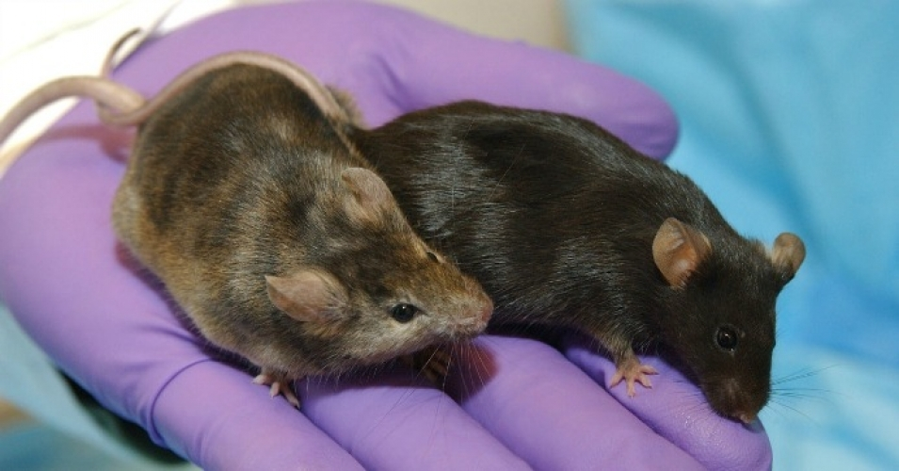

GM Mice in Research:

GM mice are used in large numbers to study human disease. Scientists use knockout mice to study human conditions where a single gene is missing or altered in the genome, such as sickle-cell anemia, muscular dystrophy, diabetes, and Parkinson’s disease. Or, scientists study a specific gene that’s been inserted in the mouse and make estimates on the effects in humans. Tumor-promoting genes called oncogenes can be inserted into the mouse’s genome, causing it to develop tumors throughout his body. These “oncomice” are commonly used to test the effectiveness of new cancer drugs. GM mice are also used extensively in the study of Alzheimer’s disease and other forms of dementia. In addition to disease, GM mice are often used for studying drug- or chemical-induced immunotoxicity, genotoxicity, carcinogenicity, and metabolic processes.

Problems with GM Mice:

There are several scientific problems with the use of GM mice to study human diseases, and their daily lives can be of poor quality. Therefore the continued largescale generation of GM mice raises compelling ethical issues that cannot be ignored.

Scientific Drawbacks:

• ***Many of the transgenic and knockout experiments fail to produce the desired result***. Even if everything goes right, only 1/8 to 1/4 of the offspring in each litter will have the desired gene mutation. Introducing a foreign gene (or knocking one out) can disrupt normal gene expression in the adjacent genes, known as ‘leakiness’.3 It is also difficult to control the precise location of insertion into the genome. As a result, many of the offspring that result from modification of a mouse’s genome are not viable as test subjects. Even worse, the modification doesn’t express itself in the offspring, which happens in 85 percent of mice who are manipulated.4 These animals are simply considered “waste” and killed.

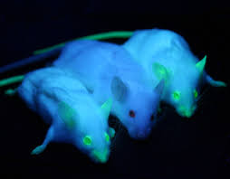

• ***Genetic-modification is a resource intensive process.*** As discussed above, genetic modification is error-prone. It can also negatively impact the fertility and survival rates of its subjects, so those that do have the desired trait are less likely to reproduce and pass that trait along to offspring.5 Because of this, large numbers of mice are used to obtain a few subjects that are healthy enough to survive the course of the experiment and have the desired modification. The mice that lack the modification or are not healthy enough are killed. This process wastes research money.

***• Disease models based off of animal data often don’t reflect human biology accurately.*** One of the drawbacks of using GM mice to study disease is that mouse and human biology doesn’t always overlap. The size difference and dissimilar physiology between the two species makes comparison difficult, and expression of the same gene can be vastly different.6 For example, humans and mice share the [γc] gene. A mutation in this gene results in a loss of T and NK cells in both humans and mice, causing severe immunological defects. However, mice also lose B cells, while humans do not.7 This distinction, which seems subtle, has enormous consequences for drug development.

***• Interpreting studies done in GM mice is difficult and error-prone.*** The differences between human and animal biology have direct implications for how results are interpreted. Promising results in studies involving GM mice have failed miserably when moved to human trials. GM mice have been widely used to test treatments for Alzheimer’s disease, with promising results. However, when treatments began clinical (human) trials they failed miserably and often had “unforeseen adverse events or negative therapeutic outcomes.”8 One treatment caused inflammation of the meninges and brain that “ultimately turns out to be worse than the original disease.”8 Relying on animal studies, geneticallymodified or otherwise, always carries a risk (see PCRM’s factsheet “Dangerous Medicine: Examples of animal-based safety tests gone wrong” for more information).

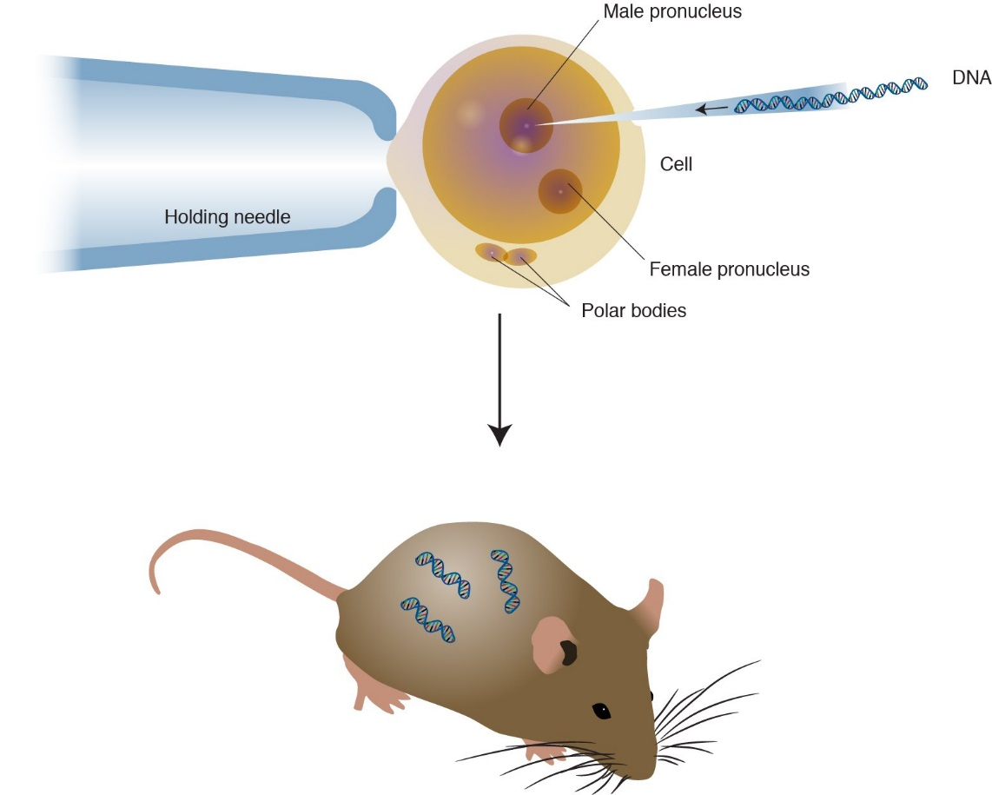

***Welfare Concerns***

***• Many procedures are painful and invasive***. A survey from the Canadian Council on Animal Care found that most procedures that GM mice undergo cause moderate to severe physical discomfort to the mouse. Typical procedures include: inducing superovulation in females, surgically placing embryos, vasectomy, and ear and tail biopsy.4 After the study has been conducted, mice are euthanized, usually via CO₂ suffocation or manual dislocation of their neck. Many of these procedures are performed without pain relief.

***• Unexpected side-effects can have a negative impact on welfare.*** In addition to the disease or condition that is induced in GM mice, transgenesis can result in any number of unanticipated side-effects, such as lameness, susceptibility to disease, stress, reduced fertility, reduced adult body weight, and immune impairment.5,10 A loss of gene function, called an insertional mutation, can also occur. Some side effects of insertional mutations include: loss of limbs (the legless mutation), craniofacial and visceral malformations, defects in the olfactory lobes and cerebrum of the brain, deafness, physical deformities, and alteration of reproductive function.4 Estimates of insertional mutation frequency in GMM range from 7-20 percent.

***• Even when nothing goes wrong, GM mice have a rough time.*** GM mice are subjected to a number of daily stressors in addition to those directly related to the experiment. Routine lab procedures such as handling, blood collection, drug dosing, and separation from other mice can cause marked and prolonged psychological and physiological stress. More than 50 percent of mice in laboratories exhibit behaviors that are indicative of distress, which can accumulate over time and result in severe mental trauma which parallels that seen in humans kept in similar conditions.

***• Questionable Relevance.*** Mice have been modified to express green fluorescence protein so that they glow in the dark, grow a structure similar to a human ear on their back, and to become cognitively deficient “Forest Gump” mice, who can run twice as far as regular mice but have little working and spatial memories. GM mice are seen as scientific “playtoys” rather than sentient beings. ***Alternatives to Using GM Mice in Research.***

Human-relevant methods of studying disease address the lack of overlap between mouse and human biology, the true contributions genetic defects have to human disease, the cost-intensive nature of using animals as subjects, and serious welfare concerns. Some alternatives include: epidemiological studies, bioinformatics, systems biology, tissue engineering, microfluidics, in vitro (human cell and tissue cultures) research, in silico (computer-based) techniques, stem cell methods, and safe human-based studies. More information about alternative methods of studying disease can be found in PCRM’s factsheet “Problems Associated with Animal Experimentation.”